Assignment 3: Convolutional Neural Networks (CNNs)
and Vision Transformers (ViTs)
CSC 592: Machine Learning Security and Privacy

Part 1: Convolutional Neural Networks

Background

Convolutional Neural Networks (CNNs) are crucial in modern artificial intelligence, particularly in image classification, due to their ability to automatically extract hierarchical features from visual data. Unlike classical machine learning methods that require manual feature engineering, CNNs use convolutional layers to detect patterns such as edges, textures, and complex structures, making them highly effective in tasks like object detection, facial recognition, and medical image analysis. CNN’s ability to learn spatial patterns enables them to generalize well across different image datasets.

In part 1 of this assignment, you will create and train a convolutional neural network (CNN) using PyTorch. You will train the CNN on the same custom dataset used in the previous lab (the Airplanes-Cars-Ships dataset). We will then compare the performance of the feedforward neural network model in the previous lab to the CNN model used in this lab.
Step by Step Guide
Step 1: Downloading the Dataset

First, create a Python application called “SimpleCNNTrainer”. In this part we will be working again with the Airplanes-Cars-Ships dataset using PyTorch. This dataset contains color images of airplanes, cars and ships.

We will create a CNN to classify an image into one of these three categories. The dataset is available as a zip file on BrightSpace (the same dataset as the previous lab). After downloading the zip file, extract it to a folder. It will contain a train and a test folder with three sub folders for images belonging to each category. The number of images in each category for the train and test parts is shown below:

airplanes ships cars
train 1000 1000 1000
test 189 200 193

Step 2: Setting up the Dataset

Create a Python application and add in the “MyDataSet.py” class as written below:

import torch
import torchvision
import numpy as np
import os
from PIL import Image

class MyDataset(torch.utils.data.Dataset):
# for Airplanes, Cars and Ships dataset
# train or test folders further have subfolders containing images
# for each category

def __init__(self, data_dir, transform=None):
self.data_dir = data_dir
self.transform = transform
self.all_image_paths = []
self.all_labels = []

for planecarship_dir in os.listdir(data_dir): # each category folder
category_path = os.path.join(data_dir, planecarship_dir)
if not os.path.isdir(category_path):
continue
if planecarship_dir == "airplanes":
label = 0
elif planecarship_dir == "cars":
label = 1
elif planecarship_dir == "ships":
label = 2
image_paths = [os.path.join(category_path, f) for f in os.listdir(category_path) if f.endswith('.jpg')]
# list of image filenames for a category, e.g., airplane, car, or ship
labels = [label for i in range(len(image_paths))]
self.all_image_paths += image_paths
self.all_labels += labels
self.num_classes = len(set(self.all_labels))

def __len__(self):
return len(self.all_image_paths)

def __getitem__(self, index):
img_path = self.all_image_paths[index]
label = self.all_labels[index]

img = Image.open(img_path).convert('RGB')
if self.transform is not None:
img = self.transform(img)
return img, label

Step 3: Setting up the Dataloader

Add in the “Utils.py” class as written below:

import torch
from MyDataSet import MyDataset
import torchvision
import matplotlib.pyplot as plt

def get_train_loader(data_dir, batch_size, transform=None):
dataset = MyDataset(data_dir, transform=transform)
data_loader = torch.utils.data.DataLoader(
dataset,
batch_size=batch_size,
shuffle=True,
num_workers=4,
pin_memory=True,
drop_last=True
)
return data_loader

def get_test_loader(data_dir, batch_size, transform=None):
dataset = MyDataset(data_dir, transform=transform)
data_loader = torch.utils.data.DataLoader(
dataset,
batch_size=batch_size,
shuffle=False,
num_workers=4,
pin_memory=True
)
return data_loader

def plot_images(images, labels):
# normalise=True below shifts [-1,1] to [0,1]
img_grid = torchvision.utils.make_grid(images, nrow=4, normalize=True)
np_img = img_grid.numpy().transpose(1,2,0) # pytorch has the order, c,w,h
# to be able to view an image, we need to change the order and
# put it in width, height, color order
plt.imshow(np_img)
plt.show()

Step 4: Creating the CNN model

Add a class called “NetworkCNN.py” with the following code in it.

import torch
import torch.nn as nn
import torch.nn.functional as F

class NetworkCNN(nn.Module):
def __init__(self):
super().__init__()
self.conv1 = nn.Conv2d(3, 32, 5) # input is color image with 3 channels
# 32 is the number of feature maps and the kernel size is 5x5

self.pool = nn.MaxPool2d(2,2)
# maxpool will be used multiple times, but defined once
# in_channels = 32 because self.conv1 output is 32 channels
self.conv2 = nn.Conv2d(32,6,5)
# 53*53 comes from the dimension of the last conv layer
self.fc1 = nn.Linear(6*53*53, 100)
self.fc2 = nn.Linear(100, 3)
self.sm = nn.Softmax(dim=1)

def forward(self, x):
x = self.pool(F.relu(self.conv1(x)))
x = self.pool(F.relu(self.conv2(x)))
x = x.view(-1, 6*53*53)
x = F.relu(self.fc1(x))
x = self.sm(self.fc2(x)) # softmax activation on final layer
return x

Step 5: Creating the Training Algorithm

In the main file (“SimpleCNNTrainer.py”) copy the following code as shown below. Where it says “#TODO: change to your filepath” change the file path to where you saved the dataset (you must make this change in two places in the code).

import sys
from torchvision import transforms
import torch
import Utils
import torch.optim as optim
from NetworkCNN import NetworkCNN

def main():
device = torch.device("cuda" if torch.cuda.is_available() else "cpu")
data_dir_train = "C:/Users/Kaleel/Desktop/Machine Learning Security and Privacy/Week 4/Dataset_PlanesCarsShips/train" #TODO: change to your filepath
data_dir_test = "C:/Users/Kaleel/Desktop/Machine Learning Security and Privacy/Week 4/Dataset_PlanesCarsShips/test" #TODO: change to your filepath
image_transforms = {
"train": transforms.Compose([
transforms.Resize((224, 224)),
transforms.ToTensor(),
transforms.Normalize([0.5, 0.5, 0.5],
[0.5, 0.5, 0.5])
]),
"test": transforms.Compose([
transforms.Resize((224, 224)),
transforms.ToTensor(),
transforms.Normalize([0.5, 0.5, 0.5],
[0.5, 0.5, 0.5])
])
}
# ToTensor converts a PIL Image or numpy.ndarray (HxWxC) in the range [0, 255]
# to a torch.FloatTensor of shape (CxHxW) in the range [0.0, 1.0]
batch_size = 16

num_epochs = 25
train_loader = Utils.get_train_loader(data_dir_train, batch_size, image_transforms["train"])
test_loader = Utils.get_test_loader(data_dir_test, batch_size, image_transforms["test"])
train_iter = iter(train_loader)
images, labels = next(train_iter) # get a batch of data e.g., 16x3x224x224
print(images[0].shape)

Utils.plot_images(images,labels) # plot images

net = NetworkCNN() # create the simple linear model
loss_criterion = torch.nn.CrossEntropyLoss()
optimizer = optim.SGD(net.parameters(), lr=0.001, momentum=0.9)

running_loss = 0
print_freq = 100
for epoch in range(num_epochs):
for i, data in enumerate(train_loader):
inputs, labels = data
optimizer.zero_grad()
outputs = net(inputs) # forward pass
loss = loss_criterion(outputs, labels)
loss.backward()
optimizer.step()
running_loss += loss.item()
#if i % print_freq == print_freq-1:
print('epoch:',epoch, i+1, running_loss/print_freq)
running_loss = 0

#-----------compute accuracy on trained model-------------
total = 0 # keeps track of how many images we have processed
correct = 0 # keeps track of how many correct images our net predicts
with torch.no_grad():
for i, data in enumerate(test_loader):
images, labels = data
outputs = net(images)
_, predicted = torch.max(outputs.data, 1)
total += labels.size()[0]
correct += (predicted == labels).sum().item()

print("Accuracy: ", correct/total)

if __name__ == "__main__":
sys.exit(int(main() or 0))
Step 6: Training the CNN model

Run “SimpleCNNTrainer.py” and record the output. Your output should appear similar to the output shown below:
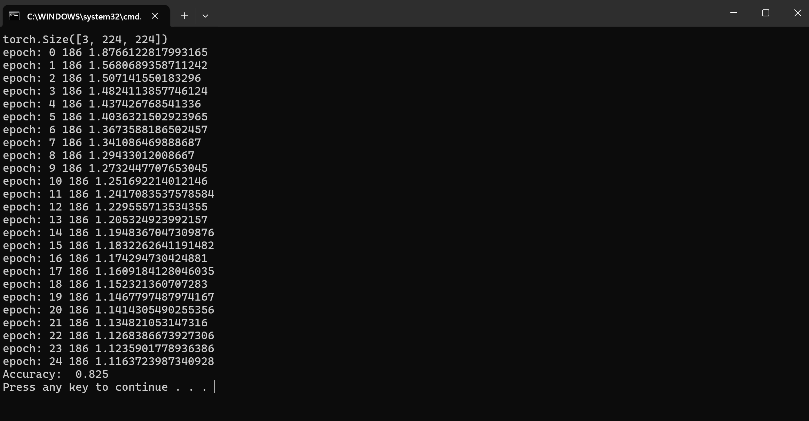
Note due to the randomized weights you may need to run the training 2-3 times to get an accuracy close to 80%.
Part 1 Exercises
Exercise 1: In your code for the lab after you create the model, measure the number of trainable parameters for the CNN model using the following code snippet:
model_parameters = filter(lambda p: p.requires_grad, net.parameters())
params = sum([numpy.prod(p.size()) for p in model_parameters])
print("Number of trainable parameters:", params)
Note: to use the code snippet you can insert it before the training occurs. You will also need to import numpy before using the code snippet. You can use the code snippet BEFORE the model is trained.
Exercise 2: Go back to your code for assignment 2 (the simple feedforward neural network model). Use the code snippet from Exercise 1 and measure the number of trainable parameters for the simple model from assignment 2?
Exercise 3: Which model is more efficient to train in terms of the number of trainable parameters?
Exercise 4: What is the size (dimension) of the input for the CNN model?
Exercise 5: What is the size (dimension) of the input for the simple feedforward model from assignment 2?
Exercise 6: Which model performed better on the Airplanes-Cars-Ships dataset, the feedforward neural network model from lab 3 or the CNN from this lab? How large was the difference in performance? Can you hypothesize on why one model performed better than the other model?

Part 2: Vision Transformers

Background

The Transformer architecture has proven to be very effective in NLP due to its attention mechanism which allows it to effectively process long text (depending on the sequence length). Prior to the famous Vision Transformer paper (An Image is Worth 16x16 Words: Transformers for Image Recognition at Scale by Alexey Dosovitskiy et al.), CNNs were considered the de facto model for computer vision. However, the paper by Dosovitskiy et al. demonstrated that Transformer architectures can also be quite effective for computer vision applications.
The main concept in the Vision Transformer (ViT) is fairly straightforward. The input image is divided into patches and each patch is converted into an embedding vector. The sequence of these embedding vectors can then be processed by a regular NLP Transformer.
The architecture of the Vision Transformer is shown below:
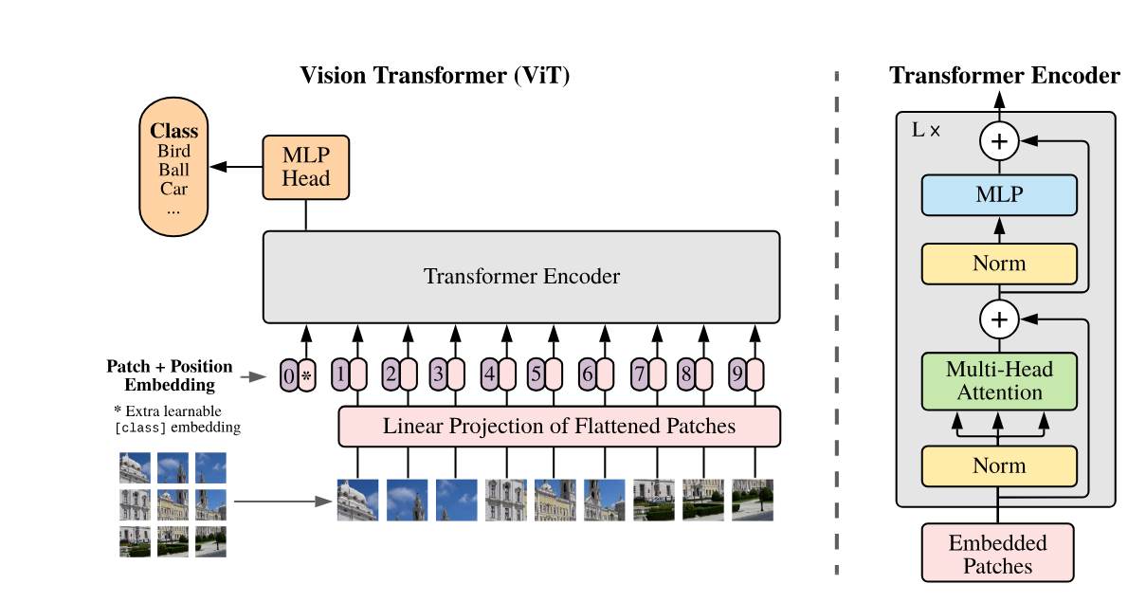
Figure Source: https://arxiv.org/abs/2010.11929
In part 2 of this assignment, you will create and train a ViT using PyTorch.
Step by Step Guide
Step 1: Code Setup

Create a new Python project called “VisionTransformerXY” (replace XY with your initials). Add three folders to the project called “data”, “checkpoint” and “models”.

Add a file called “Utils.py” with the following code in it. This file downloads the CIFAR-10 data and prepares the data loaders. Even though the image size of CIFAR-10 is 32x32, we resize each image to 224x224 and rescale the pixel values between -1 and 1 by applying the appropriate transform. This is done so that it can be trained on the Vision Transformer architecture by creating patches of size 16x16 pixels.

import torch

from torchvision import transforms, datasets
from torch.utils.data import DataLoader, RandomSampler, SequentialSampler

def get_loaders_cifar(dataset_type="CIFAR10", img_width=224, img_height=224, batch_size=16):

transform_train = transforms.Compose([
transforms.RandomResizedCrop((img_width, img_height), scale=(0.05, 1.0)),
transforms.ToTensor(),
transforms.Normalize(mean=[0.5, 0.5, 0.5], std=[0.5, 0.5, 0.5]),
]) # rescale train data between -1 to 1
transform_test = transforms.Compose([
transforms.Resize((img_width, img_height)),
transforms.ToTensor(),
transforms.Normalize(mean=[0.5, 0.5, 0.5], std=[0.5, 0.5, 0.5]),
]) # rescale test data between -1 to 1

if dataset_type == "CIFAR10":
trainset = datasets.CIFAR10(root="./data",
train=True,
download=True,
transform=transform_train)
testset = datasets.CIFAR10(root="./data",
train=False,
download=True,
transform=transform_test)
if dataset_type == "CIFAR100":
trainset = datasets.CIFAR100(root="./data",
train=True,
download=True,
transform=transform_train)
testset = datasets.CIFAR100(root="./data",
train=False,
download=True,
transform=transform_test)
train_sampler = RandomSampler(trainset)
test_sampler = SequentialSampler(testset)

train_loader = DataLoader(trainset,
shuffle=True,
batch_size=batch_size,
num_workers=4,
pin_memory=True)
test_loader = DataLoader(testset,
sampler=test_sampler,
batch_size=batch_size,
num_workers=4,
pin_memory=True)
return train_loader, test_loader, testset

Step 2: Attention Code

Add a file called “MHSelfAttention.py” to the models folder with the following code in it.

from pickle import NONE
import numpy as np
import torch
from einops import rearrange
from torch import nn

class MHSelfAttention(nn.Module):
def __init__(self, dim, heads=8, dim_head=None): # e.g., dim=768 i.e., embedding dim
super().__init__()
self.dim_head = (int(dim/heads)) if dim_head is None else dim_head
_dim = self.dim_head * heads
self.heads = heads
self.to_qkv = nn.Linear(dim, _dim * 3, bias=False)
self.W_out = nn.Linear( _dim, dim, bias=False)
self.scale_factor = self.dim_head ** -0.5

def forward(self, x, mask=None):
assert x.dim() == 3
qkv = self.to_qkv(x) # [b, n, dim*3]
# decompose to q,k,v and cast to tuple - [3,b, heads, seq length, dim_head]
q, k, v = tuple(rearrange(qkv, 'b n (d k h) -> k b h n d ', k=3, h=self.heads)) # [b, heads, seq length, dim_head]

# resulting shape will be: [batch, heads, tokens, tokens]
scaled_dot_prod = torch.einsum('b h i d , b h j d -> b h i j', q, k) * self.scale_factor

attention = torch.softmax(scaled_dot_prod, dim=-1) # attention matrix
# output for one head
out = torch.einsum('b h i j , b h j d -> b h i d', attention, v)

out = rearrange(out, "b h n d -> b n (h d)") # merge all heads into dim

return self.W_out(out) # final linear transformation WO

The above class implements the self-attention computation for the Vision Transformer model.

Step 3: Model Code

Add a file called “PositionalEncoding.py” to the “models” folder with the following code in it:

import torch
from torch import nn
from torch.autograd import Variable
import math

class PositionalEncoding(nn.Module):
def __init__(self, embedding_dim, max_seq_length=512, dropout=0.1):
super(PositionalEncoding, self).__init__()
self.embedding_dim = embedding_dim
self.dropout = nn.Dropout(dropout)
pe = torch.zeros(max_seq_length, embedding_dim)
for pos in range(max_seq_length):
for i in range(0, embedding_dim, 2):
pe[pos, i] = math.sin(pos/(10000**(2*i/embedding_dim)))
pe[pos, i+1] = math.cos(pos/(10000**((2*i+1)/embedding_dim)))
pe = pe.unsqueeze(0)
self.register_buffer('pe', pe)

def forward(self, x):
x = x*math.sqrt(self.embedding_dim)
seq_length = x.size(1)
pe = Variable(self.pe[:, :seq_length], requires_grad=False).to(x.device)
# Add the positional encoding vector to the embedding vector
x = x + pe
x = self.dropout(x)
return x

Add a file called “TransformerBlock.py” to the “models” folder with the following code in it. This class implements each layer of the transformer (referred to as the Block).

from torch import nn

from MHSelfAttention import MHSelfAttention

class TransformerBlock(nn.Module):
def __init__(self, dim, heads=8, dim_head=None, pos_embed=None, dim_linear_block=1024, dropout=0.1):
super().__init__()
self.mhsa = MHSelfAttention(dim=dim, heads=heads, dim_head=dim_head)
self.drop = nn.Dropout(dropout)
self.norm_1 = nn.LayerNorm(dim)
self.norm_2 = nn.LayerNorm(dim)

self.linear = nn.Sequential(
nn.Linear(dim, dim_linear_block),
nn.ReLU(),
nn.Dropout(dropout),
nn.Linear(dim_linear_block, dim),
nn.Dropout(dropout)
)

def forward(self, x):
y = self.norm_1(self.drop(self.mhsa(x)) + x)
return self.norm_2(self.linear(y) + y)

Add a file called “SimpleTransformer.py” to the “models” folder with the following code in it. It assembles the entire transformer architecture:

from torch import nn
from TransformerBlock import TransformerBlock
from PositionalEncoding import PositionalEncoding
import torch
from PatchEmbedding import PatchEmbedding_CNN, PatchEmbedding_Linear

class SimpleTransformer(nn.Module):
def __init__(self, dim, num_unique_tokens=10, num_layers=6, heads=8, dim_head=None, max_seq_len=1024):
super().__init__()
self.max_seq_len = max_seq_len

#self.token_emb = nn.Embedding(num_unique_tokens, dim)
self.token_emb = PatchEmbedding_CNN(emb_size=dim)
#self.token_emb = PatchEmbedding_Linear(emb_size=dim)

self.pos_enc = PositionalEncoding(dim,max_seq_length=max_seq_len)

self.block_list = [TransformerBlock(dim=dim, heads=heads, dim_head=dim_head) for _ in range(num_layers)]
self.layers = nn.ModuleList(self.block_list)

self.to_logits = nn.Sequential(
nn.LayerNorm(dim),
nn.Linear(dim, num_unique_tokens)
)

def forward(self, x, mask=None):
pos = torch.arange(0, x.shape[-1], dtype=torch.long, device='cuda').unsqueeze(0) # shape (1, t)
x = self.token_emb(x)
x = x + self.pos_enc(x)
for layer in self.layers:
x = layer(x)
return self.to_logits(x)

Step 4: Patch Embeddings and Model Metrics

Add a file called “PatchEmbedding.py” to the project with the following code in it. This file converts the patches of the image into vector embeddings so that the transformer can use these as a sequence of embedded tokens similar to an NLP transformer:

from torch import nn
from torch import Tensor
from einops.layers.torch import Rearrange
import torch

class PatchEmbedding_Linear(nn.Module):
def __init__(self, in_channels: int = 3, patch_size: int = 16, emb_size: int = 512):
self.patch_size = patch_size
super().__init__()
self.cls_token = nn.Parameter(torch.zeros(1, 1, emb_size).cuda())
self.projection = nn.Sequential(
# break-down the image in s1 x s2 patches and flat them
Rearrange('b c (h s1) (w s2) -> b (h w) (s1 s2 c)', s1=patch_size, s2=patch_size),
nn.Linear(patch_size * patch_size * in_channels, emb_size)
)

def forward(self, x: Tensor) -> Tensor:
B = x.shape[0] # batch_size
cls_tokens = self.cls_token.expand(B, -1, -1) # cls token
x = self.projection(x)
x = torch.cat((cls_tokens, x), dim=1)
return x

class PatchEmbedding_CNN(nn.Module):
def __init__(self, in_channels: int = 3, patch_size: int = 16, emb_size: int = 512):
self.patch_size = patch_size
super().__init__()
self.cls_token = nn.Parameter(torch.zeros(1, 1, emb_size).cuda())
self.projection = nn.Sequential(
# using a conv layer instead of a linear one -> performance gains
nn.Conv2d(in_channels, emb_size, kernel_size=patch_size, stride=patch_size),
Rearrange('b e (h) (w) -> b (h w) e'),
)

def forward(self, x: Tensor) -> Tensor:
B = x.shape[0] # batch_size
cls_tokens = self.cls_token.expand(B, -1, -1) # cls token
x = self.projection(x)
x = torch.cat((cls_tokens, x), dim=1)
return x

Add a file called “TrainValidateWrapper.py” with the following code in it. This class wraps the Transformer model and provides training and testing metrics for the model:

import torch
from torch import nn
import torch.nn.functional as F

class TrainValidateWrapper(nn.Module):
def __init__(self, net):
super().__init__()
self.model = net
self.max_seq_len = net.max_seq_len

@torch.no_grad()
def validate(self, x, y):
self.model.eval()
out = self.model(x)
logits_reorg = out[:,0,:]
actual_recog = logits_reorg.argmax(dim=1)
count_correct = (actual_recog == y).sum().item()
return count_correct

def forward(self, x, y):
out = self.model(x)
logits_reorg = out[:,0,:]
loss = F.cross_entropy(logits_reorg,y)
return loss

Step 5: Main Code

In your main Python file type the following code:

import random
import tqdm
import numpy as np

import torch
import torch.optim as optim
from TrainValidateWrapper import TrainValidateWrapper
from SimpleTransformer import SimpleTransformer
from PatchEmbedding import PatchEmbedding_CNN
import Utils
import sys
import math
import os

# ------constants------------
NUM_EPOCHS = 20
BATCH_SIZE = 16
GRADIENT_ACCUMULATE_EVERY = 1
LEARNING_RATE = 1e-4 # does not learn with 1e-3
VALIDATE_EVERY = 1
SEQ_LENGTH = 197 # 14x14 + 1 for cls_token
RESUME_TRAINING = True # set to false to start training from beginning
#---------------------------

best_test_accuracy = 0

def count_parameters(model): # count number of trainable parameters in the model
return sum(p.numel() for p in model.parameters() if p.requires_grad)

def configure_optimizers(mymodel):
"""
This long function is unfortunately doing something very simple and is being very defensive:
We are separating out all parameters of the model into two buckets: those that will experience
weight decay for regularization and those that won't (biases, and layernorm/embedding weights).
We are then returning the PyTorch optimizer object.
"""

# separate out all parameters to those that will and won't experience regularizing weight decay
decay = set()
no_decay = set()
whitelist_weight_modules = (torch.nn.Linear, )
blacklist_weight_modules = (torch.nn.LayerNorm, torch.nn.Embedding) #,torch.nn.Parameter, torch.nn.Conv2d
for mn, m in mymodel.named_modules():
for pn, p in m.named_parameters():
fpn = '%s.%s' % (mn, pn) if mn else pn # full param name
# random note: because named_modules and named_parameters are recursive
# we will see the same tensors p many many times. but doing it this way
# allows us to know which parent module any tensor p belongs to...
if pn.endswith('bias'):
# all biases will not be decayed
no_decay.add(fpn)
elif pn.endswith('weight') and isinstance(m, whitelist_weight_modules):
# weights of whitelist modules will be weight decayed
decay.add(fpn)
elif pn.endswith('weight') and isinstance(m, blacklist_weight_modules):
# weights of blacklist modules will NOT be weight decayed
no_decay.add(fpn)
elif fpn.startswith('model.token_emb'):
#print(fpn)
no_decay.add(fpn) # change to no_decay if using PatchEmbedding_CNN
#else:
# print(fpn)

# validate that we considered every parameter
param_dict = {pn: p for pn, p in mymodel.named_parameters()}
inter_params = decay & no_decay
union_params = decay | no_decay
assert len(inter_params) == 0, "parameters %s made it into both decay/no_decay sets!" % (str(inter_params), )
assert len(param_dict.keys() - union_params) == 0, "parameters %s were not separated into either decay/no_decay set!" \
% (str(param_dict.keys() - union_params), )

# create the pytorch optimizer object
optim_groups = [
{"params": [param_dict[pn] for pn in sorted(list(decay))], "weight_decay": 0.1},
{"params": [param_dict[pn] for pn in sorted(list(no_decay))], "weight_decay": 0.0},
]
optimizer = torch.optim.AdamW(optim_groups, lr=LEARNING_RATE, betas=(0.9,0.95))
return optimizer

def main():
global best_test_accuracy
vision_model = SimpleTransformer(
dim = 768, # embedding
num_unique_tokens = 10, # for CIFAR-10, use 100 for CIFAR-100
num_layers = 12,
heads = 8,
max_seq_len = SEQ_LENGTH,
).cuda()

model = TrainValidateWrapper(vision_model)
model.cuda()
pcount = count_parameters(model)
print("count of parameters in the model = ", pcount/1e6, " million")

train_loader, val_loader, testset = Utils.get_loaders_cifar(dataset_type="CIFAR10", img_width=224, img_height=224, batch_size=BATCH_SIZE)
#optim = torch.optim.Adam(model.parameters(), lr = LEARNING_RATE) # optimizer
optim = configure_optimizers(model)

# --------training---------
if RESUME_TRAINING == False:
start = 0
else:
checkpoint_data = torch.load('checkpoint/visiontrans_model.pt')
model.load_state_dict(checkpoint_data['state_dict'])
optim.load_state_dict(checkpoint_data['optimizer'])
start = checkpoint_data['epoch']
best_test_accuracy = checkpoint_data['test_acc']
print('best test accuracy from restored model=', best_test_accuracy)
for i in tqdm.tqdm(range(start,NUM_EPOCHS), mininterval = 10., desc = 'training'):
for k, data in enumerate(train_loader):
model.train()
total_loss = 0
for __ in range(GRADIENT_ACCUMULATE_EVERY):
x, y = data #next(train_loader)
x = x.cuda()
y = y.cuda()
loss = model(x, y)
loss.backward()
if (k%500 == 0):
print(f'training loss: {loss.item()} -- iteration = {k}')

torch.nn.utils.clip_grad_norm_(model.parameters(), 1.0)
optim.step()
optim.zero_grad()

if i % VALIDATE_EVERY == 0:
model.eval()
val_count = 3000
total_count = 0
count_correct = 0
with torch.no_grad():
for v, data in enumerate(val_loader):
x, y = data
x = x.cuda()
y = y .cuda()
count_correct = count_correct + model.validate(x,y)
total_count = total_count + x.shape[0]
accuracy = (count_correct/total_count)*100
print("\n-------------Test Accuracy = ", accuracy,"\n")
if accuracy > best_test_accuracy:
print("----------saving model-----------------")
checkpoint_data = {
'epoch': i,
'state_dict': model.state_dict(),
'optimizer': optim.state_dict(),
'test_acc' : accuracy
}
ckpt_path = os.path.join("checkpoint/visiontrans_model.pt")
torch.save(checkpoint_data, ckpt_path)
best_test_accuracy = accuracy
model.train()
# if i > 50000:
# optim.param_groups[0]['lr'] = 1e-4

if __name__ == "__main__":
sys.exit(int(main() or 0))

Examine the above code carefully to see how the model training is set up. To start training first change the variable RESUME_TRAINING from “true” to “false” (since you will be starting the training from scratch. Run the code. If you train the model, you will get an accuracy of around 73%. For 20 epochs of training, your accuracy may be around 50%.

Part 2 Exercises
Exercise 7: Record a screenshot of the code after the model has finished training.
Deliverables
Submit the following two items on Brightspace:
Deliverable #1: A word or pdf document that contains your answers to the 7 exercises.
Deliverable #2: A copy of your code for each part as a zip file (the .py files zipped).

